SECURE CODING GUIDELINES



DOCUMENT
SECURE CODING GUIDELINES
PREPARED BY
Rajeev Jaiswal
DATE
June, 2023

INDEX

1. Purpose 3
2. Scope 3
3. Definition 3
4. Guidelines 3
a. Input Validation 3
b. Authentication and Authorization 3
c. Data Encryption 4
d. Error Handling 4
e. Session Management 4
f. Code Reviews 4
5. Procedure 4
a. Security Training 4
b. Secure Coding Standards 4
c. Use of Third-Party Libraries 4
d. Security Testing 5
e. Secure DevOps Practices 5
f. Use of Environment 5
6. Security Vulnerabilities Checklist for Developers (Best Practices) 5
a. General Practices 5
b. Output Encoding 6
c. Authentication and Password Management 6
d. Session Management 6
e. Access Control 7
f. Cryptographic Practices 7
g. Error Handling and Logging 7
h. Data Protection 8
i. Communication Security 8
j. System Configuration 8
k. Database Security 8
l. File Management 9
m. Using Github / code sharing / collaboration tools 9
n. Firebase Misconfigurations 10
o. AWS Bucket Misconfiguration 11

Purpose
The purpose of these Secure Coding Guidelines is to establish a set of principles, practices, and procedures that developers at Zediant Technologies must follow to ensure the creation of secure and resilient software applications. These guidelines aim to prevent security vulnerabilities, protect user data, and maintain the integrity of our applications.

Scope
These guidelines apply to all developers involved in the software development process at Zediant Technologies. They cover the entire development lifecycle, from design and coding to testing and deployment.

Definition
Secure coding refers to the practice of writing code with a focus on preventing security vulnerabilities and protecting against potential threats.
Security vulnerabilities are weaknesses or flaws in the code that can be exploited to compromise the confidentiality, integrity, or availability of the software or the data it processes.
Term | Definition
ISMS | Information Security Management System
IT | Information Technology
MFA | Multi Factor Authentication

Guidelines
These guidelines are intended for all developers actively engaged in the development of applications. Adhering to these guidelines is crucial to ensure the consistent and secure development of software products. By following these best practices, developers contribute to the creation of high-quality and reliable applications.

Input Validation
- Validate and sanitize all user inputs to prevent injection attacks.
- Use parameterized queries for database interactions.
- Avoid concatenating user inputs into queries.

Authentication and Authorization
- Implement strong authentication mechanisms.
- Enforce the principle of least privilege.
- Regularly review and update access controls.

Data Encryption
- Employ encryption for sensitive data during transmission and storage.
- Use industry-standard encryption algorithms.
- Ensure secure management of encryption keys.

Error Handling
- Handle errors gracefully without exposing sensitive information.
- Provide generic error messages to users.
- Log detailed error information for internal use.

Session Management
- Use secure session management techniques.
- Implement secure session tokens.
- Regularly invalidate and regenerate session tokens.

Code Reviews
- Conduct regular code reviews with a focus on security.
- Encourage collaboration and knowledge sharing among development teams.

Procedure
This comprehensive development procedure is designed for all developers actively participating in application development. Adhering to this procedural framework is essential to ensure a systematic and efficient development process, resulting in the creation of high-quality and reliable applications.

Security Training
- Provide ongoing security training for developers.
- Keep developers informed about the latest security threats and best practices.

Secure Coding Standards
- Adopt and adhere to secure coding standards.
- Follow consistent naming conventions, code organization, and documentation practices.

Use of Third-Party Libraries
- Regularly update and patch third-party libraries.
- Only use well-maintained and reputable libraries with known security histories.

Security Testing
- Incorporate regular security testing, including static code analysis, dynamic analysis, and penetration testing.
- Identify and remediate vulnerabilities promptly.

Secure DevOps Practices
- Integrate security into the entire development lifecycle.
- Implement continuous integration, continuous deployment, and ongoing monitoring.

Use of Environment
- Production Environment: The production environment contains applications or services which are intended for the end-users. Before moving anything to the production environment or even making slight modifications, the permission of involved parties must be taken and tracked using Email.
- Pre-Production/Staging/QA: The applications need to be thoroughly verified using different mechanisms i.e automated tools, manual tools and QA Testing to remove the fail cases. If any security vulnerabilities still exist, prior permission shall be taken by the cybersecurity team before deploying it to production.

Security Vulnerabilities Checklist for Developers (Best Practices)
This checklist outlines best practices for developers to identify and mitigate security vulnerabilities during the application development process. Adhering to these guidelines is essential to enhance the security posture of software products and protect against potential threats.

General Practices
- Input Validation
User Input is one of the most important entry points for any application, this gives attackers a pathway to inject various attack vectors inside the application. Therefore, it is necessary to take care of how our applications process the user input which is received. Priority must be given to filter out and sanitize while rendering user-controllable values to any application. For the same, we recommend the following measures to follow while writing code.
- Validation-check
User Input validation must also be performed on the server-side rather than depending on checks on client-side as it can be bypassed.
- Data-type
Input type must be checked with required data type eg- string, integer and also reject unwanted input types, eg: a function needs only integer in such a case if not required reject boolean or string values
- Add check on data type
In case of integer inputs allow inputs under a specific range only as required by application which would prevent overflow issues.
- Sanitization
Input sanitization should always be carried in order to block harmful and unwanted characters
- Encoding
Encode CR & LF characters (\r, \n) so that even when they’re supplied, they aren’t recognized and processed by the server.
- Central Validation
There should be a centralized input validation method that can be called for validation each time.
- Validate client data
Validate all client provided data before processing, including all parameters, URLs and HTTP header content (e.g. Cookie names and values). Validate data range and length and if failed it must be rejected.

Output Encoding
- Conduct all encoding on a trusted system
- Encode all characters unless they are known to be safe for the intended interpreter
- Sanitization: Input sanitization should always be carried out in order to block harmful and unwanted characters.

Authentication and Password Management
- All authentication controls should fail securely without exposing information.
- Use a centralized implementation for all authentication controls, including libraries that call external authentication services.
- All authentication controls must be enforced on a trusted system
- Password hashing must be implemented on a trusted system.
- Authenticate all the Web Pages/API/ Resources/ unless it is meant to be public.
- Authentication error should not clearly state which start of the authentication system is wrong. Ex: “Username or Password is wrong”.
- Use only HTTP POST requests to transmit authentication credentials.
- Enforce password length requirements established by policy or regulation.
- Notify users when a password reset occurs.
- Re-authenticate users prior to performing critical operations.
- Use MFA for highly sensitive or high-value transactional accounts

Session Management
- Session identifier creation must always be done on a trusted system.
- Set the domain and path for cookies containing authenticated session identifiers to an appropriately restricted value for the site.
- Generate a new session identifier on any re-authentication.
- JSON Web Token must be implemented by following the standard guidelines.
- The token secret must be stored in a key management service and every time the token must be verified to validate the status of the token.

Access Control
- Access controls should fail securely.
- Restrict access to protected URLs to only authorized users.
- Restrict access to protected functions to only authorized users.
- Restrict access to services to only authorized users.
- Restrict access to application data to only authorized users.
- Enforce application logic flows to comply with business rules.
- Restrict access to application data to only authorized users.
- Create an Access Control Policy to document application business rules, types and authorization access criteria.

Cryptographic Practices
- All cryptographic functions used to protect secrets from the application user must be implemented on a trusted system.
- Protect master secrets from unauthorized access.
- Make use of the Key Management service to store the important key files.
- Cryptographic modules should fail securely.
- Establish and utilize a policy and process for how cryptographic keys will be managed.

Error Handling and Logging
- Do not disclose sensitive information in error responses, including system details, session identifiers or account information.
- Use error handlers that do not display debugging or stack trace information
- Implement generic error messages and use custom error pages.
- The application should handle application errors and not rely on the server configuration.
- Error handling logic associated with security controls should deny access by default.
- Restrict access to logs to only authorized individuals.
- Log all input validation failures.
- Log all access control failures
- Log all system exceptions
- Log attempts to connect with invalid or expired session tokens
- Log all apparent tampering events, including unexpected changes to state data.

Data Protection
- Implement least privilege, restrict users to only the functionality, data and system information that is required to perform their tasks.
- Protect all cached or temporary copies of sensitive data stored on the server from unauthorized access and purge those temporary working files as soon as they are no longer required.
- Encrypt highly sensitive stored information, like authentication verification data, even on the server-side. Always use well-vetted algorithms, see "Cryptographic Practices".
- Protect server-side source code from being downloaded by a user.
- Do not store passwords, connection strings or other sensitive information in clear text or in any non cryptographically secure manner on the client-side.
- Remove comments in user-accessible production code that may reveal backend systems or other sensitive information.
- Do not include sensitive information in HTTP GET request parameters.
- The application should support the removal of sensitive data when that data is no longer required.

Communication Security
- Implement encryption for the transmission of all sensitive information. This should include TLS for protecting the connection and may be supplemented by discrete encryption of sensitive files or non HTTP based connections.
- TLS certificates should be valid and have the correct domain name, not be expired, and be installed with intermediate certificates when required.
- Failed TLS connections should not fall back to an insecure connection.
- Utilize TLS connections for all content requiring authenticated access and for all other sensitive information.
- Specify character encodings for all connections.
- Filter parameters containing sensitive information from the HTTP referer, when linking to external sites.

System Configuration
- Turn off directory listings
- Ensure servers, frameworks and system components are running the latest approved version.
- Ensure servers, frameworks and system components have all patches issued for the version in use
- Remove all unnecessary functionality and files.
- Restrict the web server, process and service accounts to the least privileges possible.
- When exceptions occur, fail securely.

Database Security
- Use strongly typed parameterized queries.
- Utilize input validation and output encoding and be sure to address meta characters. If these fail, do not run the database command.
- Ensure that variables are strongly typed
- Use secure credentials for database access
- The application should use the lowest possible level of privilege when accessing the database.
- Use stored procedures to abstract data access and allow for the removal of permissions to the base tables in the database.
- Close the connection as soon as possible.
- Remove or change all default database administrative passwords. Utilize strong passwords/phrases or implement multi-factor authentication.
- Turn off all unnecessary database functionality
- Disable any default accounts that are not required to support business requirements.

File Management
- Do not pass user supplied data directly to any dynamic include function.
- Require authentication before allowing a file to be uploaded
- Limit the type of files that can be uploaded to only those types that are needed for business purposes
- Validate uploaded files are the expected type by checking file headers. Checking for file type by extension alone is not sufficient
- Do not save files in the same web context as the application. Files should either go to the content server or in the database.
- Prevent or restrict the uploading of any file that may be interpreted by the web server.
- Turn off execution privileges on file upload directories
- Do not pass user supplied data into a dynamic redirect. If this must be allowed, then the redirect should accept only validated, relative path URLs
- Do not pass directory or file paths, use index values mapped to pre-defined list of paths
- Never send the absolute file path to the client
- Ensure application files and resources are read-only
- Scan user uploaded files for viruses and malware

Using Github / code sharing / collaboration tools
- Don't mark your code public / don’t make critical repositories public.
- Do not put config details in the source code.
- Don’t commit dependencies into source control.
- Don’t commit local configuration into source control.
- Always create a meaningful git ignore file.
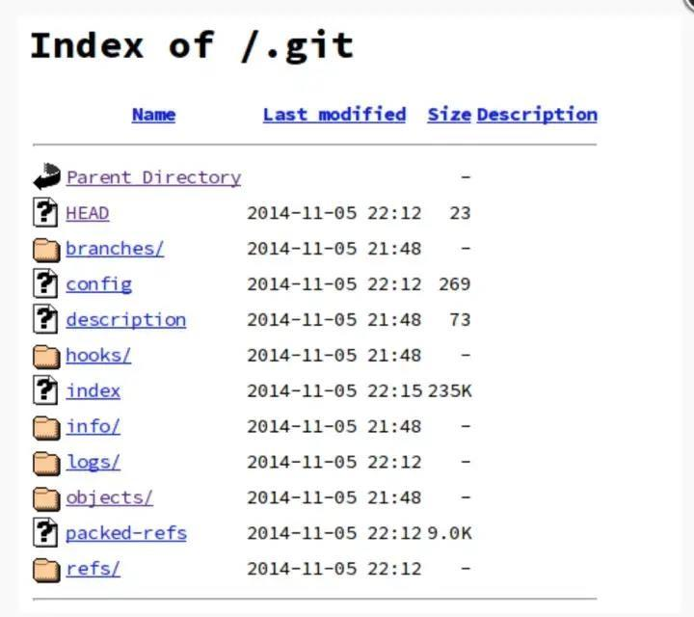
Note: Such misconfiguration results in complete source code disclosure of the application, and makes it quite easy for malicious actors to get a hold of your source code.

Firebase Misconfigurations
- Properly Configured Firebase
By default, the database settings for a database are read and write protected, meaning the read and write access is not allowed. To store real-time data, write access to the database must be enabled by setting the “write” flag to “true.” Remember, that read access is still disabled, and the “read” flag is set to “false,” as shown in the following screenshot.
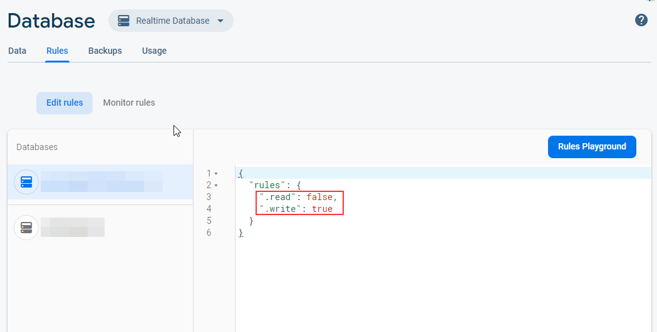
- Misconfigured Firebase
While testing the functioning of the database and checking the flow of data, developers often make the database public. They set the value of both the “read” and “write” flag to “true.” If the “read” flag is set to “true,” it means that an adversary can read the content of the database without any authentication.
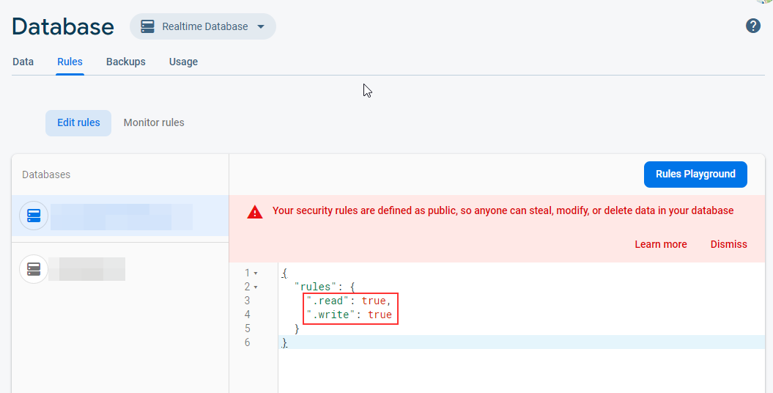
- Misconfigured Firebase exposing sensitive real time data
Instances of misconfigured Firebase configurations can inadvertently expose sensitive real-time data, posing a significant security risk. It is crucial to implement proper security measures and access controls within Firebase settings to prevent unauthorized access and potential data breaches.

AWS Bucket Misconfiguration
- Block Public Access setting should be enabled
- S3 buckets should prohibit public read access
- S3 buckets should prohibit public write access
- S3 buckets should have server-side encryption enabled
- S3 buckets should require requests to use Secure Socket layer
- Amazon S3 permissions granted to other AWS accounts in bucket policies should be restricted
- S3 Block Public Access setting should be enabled at the bucket level
